

CAPSTONE PROJECT REPORT
Report 5 – Software Test Documentation

– Ho Chi Minh, March 2026 –
Table of Contents
I. Record of Changes 3
II. Testing Documentation 4
1. Scope of Testing 4
1.1 Features and Functions to Be Tested 4
2. Test Strategy 8
2.1 Testing Types 8
2.2 Test Levels 9
2.3 Supporting Tools 9
3. Test Plan 9
3.1 Human Resources 9
3.2 Test Environment 10
3.3 Test Milestones 10
4. Test Cases 11
5. Test Reports 12

I. Record of Changes
Date | A*  M, D | In charge | Change Description
26/2/2026 | A | Anh Tú | Add: 1. Scope of Testing
5/3/2026 | A | Anh Tú | Add:  1.1 Features and Functions to Be Tested  2.1 Testing Types  2.2 Test Levels  2.3 Supporting Tools  3.1 Human resources  3.2 Test Environment  3.3 Test Milestones
14/03/2026 | A | Vạn Hào | 5. Test Reports Round 1
8/04/2026 | A | Vạn Hào | 5. Test Reports Round 2
19/04/2026 | A | Vạn Hào | 5. Test Reports Round 3
10/04/2026 | A | Trịnh Nhân | 4. Test Cases
14/04/2026 | A | Trịnh Nhân | 5. Test Reports
*A - Added M - Modified D - Deleted

II. Testing Documentation

1. Scope of Testing

1.1 Features and Functions to Be Tested
- Core Features: Authentication (JWT), User Management (Candidate/Recruiter/Admin), CV Upload, Job Posting, Job Application, Company Profile Management, Job search (filter advanced)
- AI Features: Resume Parsing, JD CV Matching score, Score weight matrix, Resume Improvement Suggestions, Candidate Recommendation
- Business Features: Subscription & Payment, Usage limit, Talent Sourcing, Application Tracking, Export Shortlist
- Admin Features: Company Verification, User Moderation, Revenue report, Content Moderation (Banned Keywords)
Feature | Function | Role | Description
Authentication | Candidate Registration | Guest | Test email validation, duplicate detection, password strength, successful registration flow
Authentication | User Login | Guest | Test JWT generation, invalid credentials handling session timeout
Authentication | Company Registration | Guest (Recruiter) | Test business license upload, form validation, pending approval status assignment
Authentication | Forgot Password | Guest | Test reset email delivery, token expiration, password update validation
Authentication | Change Password | Authenticated User | Test current password verification, new password requirements, confirmation matching
Authentication | Logout | Authenticated User | Test session termination, token invalidation, redirect to public pages
Resume Management | Upload resume | Candidate | Test file type (PDF/DOCX), size limits, S3 storage success
Resume Management | Parse resume | Candidate | Test AI extraction accuracy, corrupted file handling, JSON output structure
Resume Management | Set parsed resume as profile | Candidate | Test profile data mapping, primary designation, switching between resumes
Resume Management | View resume | Candidate | Test parsed data display, PDF preview/download
Resume Management | Update resume | Candidate | Test metadata edit, deletion with confirmation
Resume Management | Create resume | Candidate | Test create new resume with template, field validation, export resume
Job Management | Create Job | Recruiter | Test field validation, skill tag assignment, deadline setting, successful job post creation
Job Management | Update job | Recruiter | Test field editing, re-validation on save, restriction on editing closed/expired jobs
Job Management | Change job status | Recruiter, Admin | Test status transitions, admin force-close, unauthorized change prevention
Job Management | Save draft job | Recruiter | Test partial form save, draft persistence across sessions, draft-to-publish flow
Job Application | Apply job | Candidate | Test requirement validation, CV selection, success notification
Job Application | View apply status | Candidate | Test status display, timeline tracking, viewed indicator
Job Application | View apply history | Candidate | Test chronological listing, filtering, pagination, empty states
Job Application | Save job / View saved jobs | Candidate | Test bookmark add/remove, persistence across sessions, job expiration handling
Job Application | Change apply status | Recruiter | Test status transitions
Job Application | View application | Recruiter | Test application display, filtering, resume file, AI scoring and analysis
Company Management | View company | Guest, User | Test public profile display, search visibility, link validation
Company Management | Manage company profile | Recruiter | Test CRUD operations, logo upload, industry selection, location mapping
Company Management | Verify company registration | Admin | Test approval workflow (Approve/Reject), document verification
Company Management | Ban company | Admin | Test immediate suspension effect, unban functionality
Plan management | Create plan | Admin | Test pricing configuration, feature bundling, duration setting, validation
Plan management | Update plan | Admin | Test editing without affecting subscribers, deprecation
Plan management | View plan | Guest, User | Test feature comparison, pricing clarity, upgrade/downgrade paths
Plan management | Config plan prices | Admin | Test currency formatting, promotional pricing
Subscriptions | View subscriptions | Root Recruiter, Candidate | Test plan details display, renewal dates
Subscriptions | Add subscription | Admin | Test flow admin manual add subscriptions for candidate or company
Subscriptions | Purchase addons subscription | Root Recruiter | Test credit top-up, immediate availability, expiration
Usage limit | View limit quota | Root Recruiter, Candidate | Test quota display accuracy, reset countdown, warning alerts at thresholds
Usage limit | Limit reset | Admin | Test automatic monthly reset, manual reset, notification
Payment | Purchase subscription | Recruiter, Candidate | Test payment callback, failure handling, receipt generation, feature unlock
Payment | Purchase add-ons package | Root recruiter
Payment | View revenue report | Admin | Test financial aggregation, date filCantering, chart accuracy
Notification | View notification | Candidate, Recruiter, Admin | Test real-time counter, read/unread status, delete/archive, pagination
Notification | Email sending | Candidate, Recruiter, Admin | Test SMTP configuration, template rendering with variables
Manage Account | Update Account Status | Candidate, Admin | Test ban/activate workflows, automatic logout
Manage Account | View All Accounts | Candidate, Recruiter, Admin | Test filtering by role/status, search functionality
AI Implement | AI suggest improve resume | Guest | Test suggestion relevance, keyword recommendations, dismiss/apply actions
AI Implement | JD & CV matching score | Recruiter | Test score accuracy (0-100), semantic matching, skill weight application
External service | Partner career page | Recruiter,  Guest | Test external API integration, job sync, click tracking, error handling
External service | API matching | Recruiter | Test third-party matching integration, data transformation, response times
External service | API parsing | Recruiter | Test external parsing accuracy, error handling, cost tracking per call

2. Test Strategy

2.1 Testing Types
Test Type | Objective | Technique | Completion Criteria
Functional Testing | Verify system functions align with requirements | Requirement-based test cases; Positive/negative testing; Boundary value analysis | All functional cases executed; No critical defects open
Unit Testing | Validate individual code units in isolation | JUnit 5 + Mockito; White-box testing; Mock external dependencies | Code coverage 70%; 100% tests pass
Integration Testing | Verify component interactions | Manual API testing via Swagger/Postman; Data flow validation | API response 3s; Data consistency 100%; No 5xx errors
UI/UX Testing | Ensure interface consistency and usability | Manual cross-browser testing (Chrome, Edge); Responsive verification | No broken layouts; Intuitive navigation; All elements render correctly
Security Testing | Validate authentication and data protection | RBAC verification; SQL injection/XSS attempts; File upload security | No unauthorized access; Secure file handling; Validated JWT implementation
Acceptance Testing | Confirm system meets business requirements | End-to-end workflows with stakeholders; Real-world scenario validation | Stakeholder approval; All critical use cases validated

2.2 Test Levels
Type of Tests | Test Level
Type of Tests | Unit | Integration | System | Acceptance
Functional Testing | X | X | X | X
Unit Testing | X
UI/UX Testing |  |  | X | X
Security Testing | X | X | X
Integration Testing |  | X

2.3 Supporting Tools
Purpose | Tool | Vendor/In-house | Version
Unit Testing | JUnit 5 | Eclipse Foundation | 5.10+
Mocking | Mockito | Mockito | 5.8+
Coverage | JaCoCo | Eclipse Foundation | 0.8.11+
API Testing | Swagger UI | Open Source | 3.0+
Database | DataDrip | JetBrain | Latest
Bug Tracking | Jira | Atlassian | Latest
Test Management | Google Sheets | In-house | Latest

3. Test Plan

3.1 Human Resources
Worker/Doer | Role | Specific Responsibilities/Comments
Dang Mai Anh Tu | Leader | Overall planning, test review, distributing test tasks to team members, integration testing, unit test
Chau Phu Hao | Member | Write test case and execute test
Nguyen Si Van Hao | Member | Write test case and execute test
Trinh Thi Thuy Nhan | Member | Write test case and execute test

3.2 Test Environment
Purpose | Tool | Provider | Version/Specs
Development | Localhost | Developer | Java 21, Spring Boot 3.x, React
Staging Server | VPS Ubuntu 22.04 | Digital Ocean | 2 vCPU, 4GB RAM, 40GB SSD
Database | PostgreSQL | Self-hosted | 16.x
File Storage | AWS S3 | AWS | Latest
Payment Gateway | Sepay Sandbox | Sepay | Latest API v2.0, test credentials
Client Browser | Chrome | Local | Latest stable version

3.3 Test Milestones
Milestone Task | Start Date | End Date
Phase 1: Unit Testing Setup & Core Modules | Week 7 | Week 7
Phase 2: Feature Testing (Auth, Profile, Job) | Week 8 | Week 8
Phase 3: Integration & Payment Testing | Week 9 | Week 9
Phase 4: System Testing & Security Validation | Week 10 | Week 10
Phase 5: UAT & Final Stabilization | Week 11 | Week 11

4. Test Cases
- Unit Test Cases: Report5_Unit Test
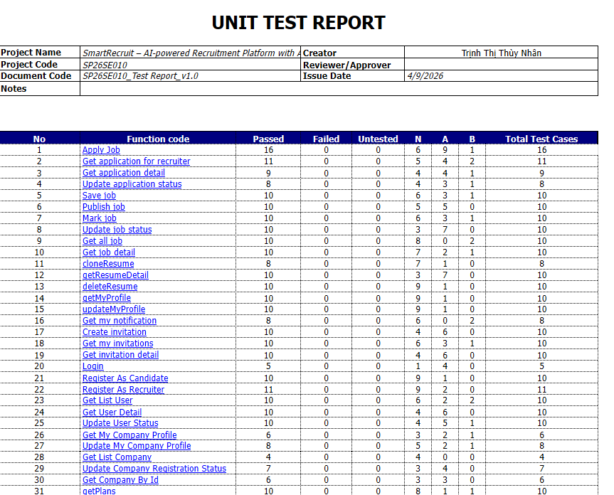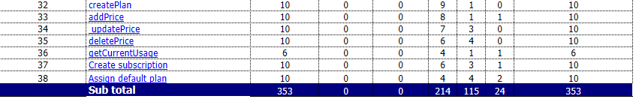

- Other Test Cases (IT, ST, AT): Report5_Test Report
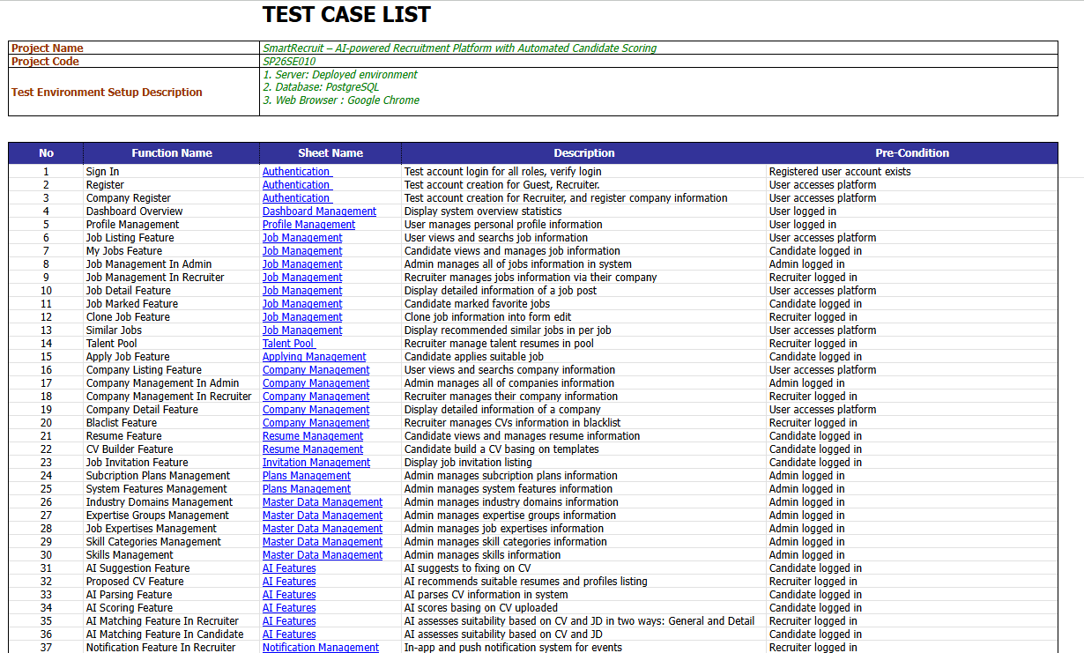
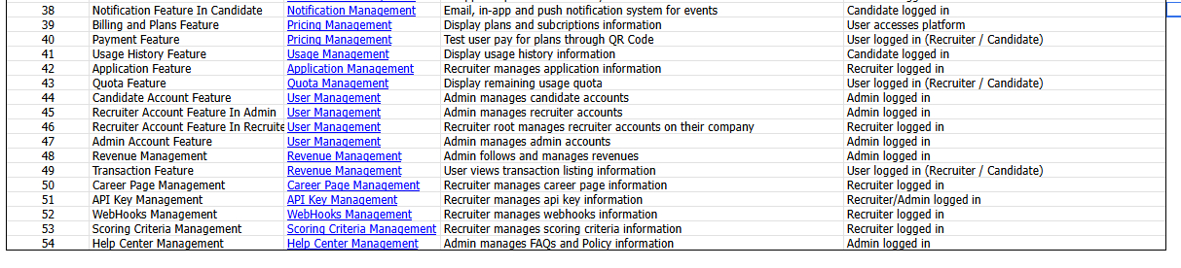

5. Test Reports
- Unit Test Report
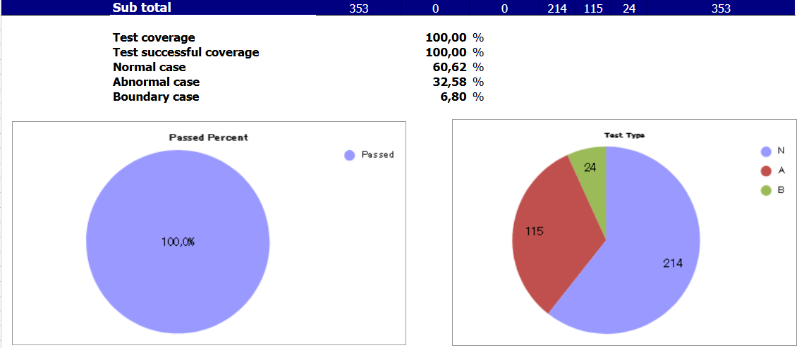

- Integration Test Report
